The Bavaria C45

EUR 505,000

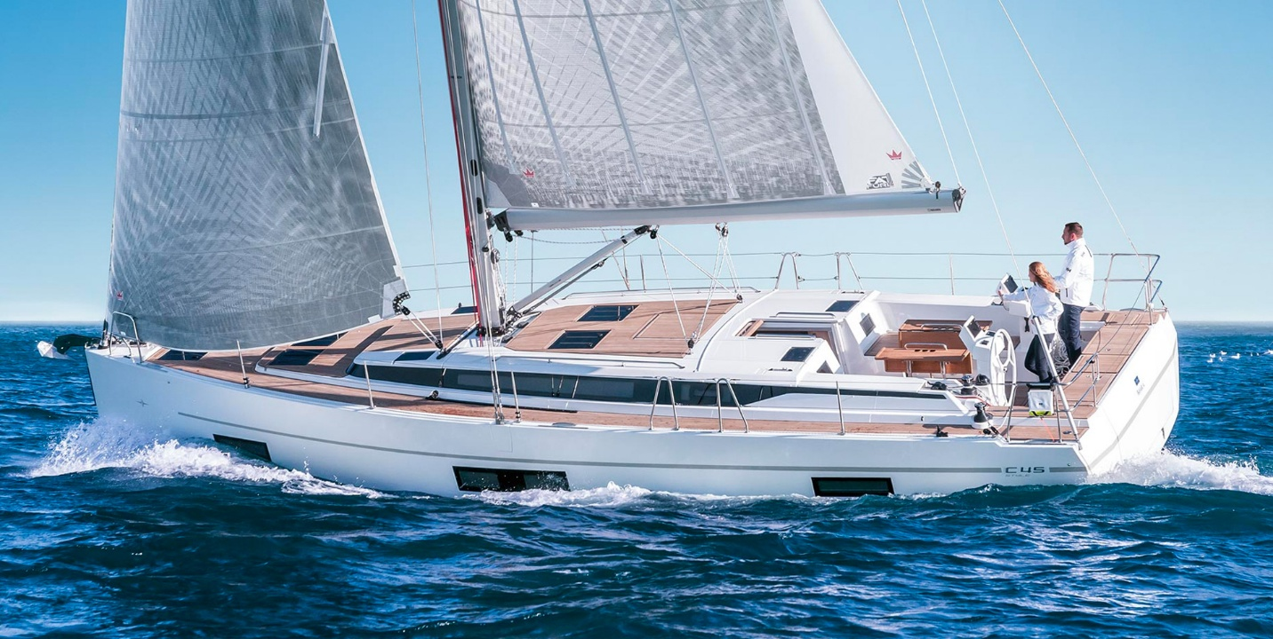

## Asking price: **EUR 505,000**

## Built: **2012, Berlin, Germany**

## Length: **68.2m (223.6ft)**

## Cabins: **5**

## Berths: **6**

# Description:

# Pure sailing pleasure.

### When we designed the BAVARIA C45, we wanted to create a yacht which people would feel completely at home on – with features like the huge bathing platform, big cockpit and bright saloon – and also a yacht of the utmost flexibility. There are two versions available: ‘Holiday’ and ‘Style’.

### Furthermore, this is the only yacht in its class available in a five-cabin version as well as three and four cabins, and which has a dinghy garage for a tender. The new BAVARIA C45 is an absolute all-rounder.